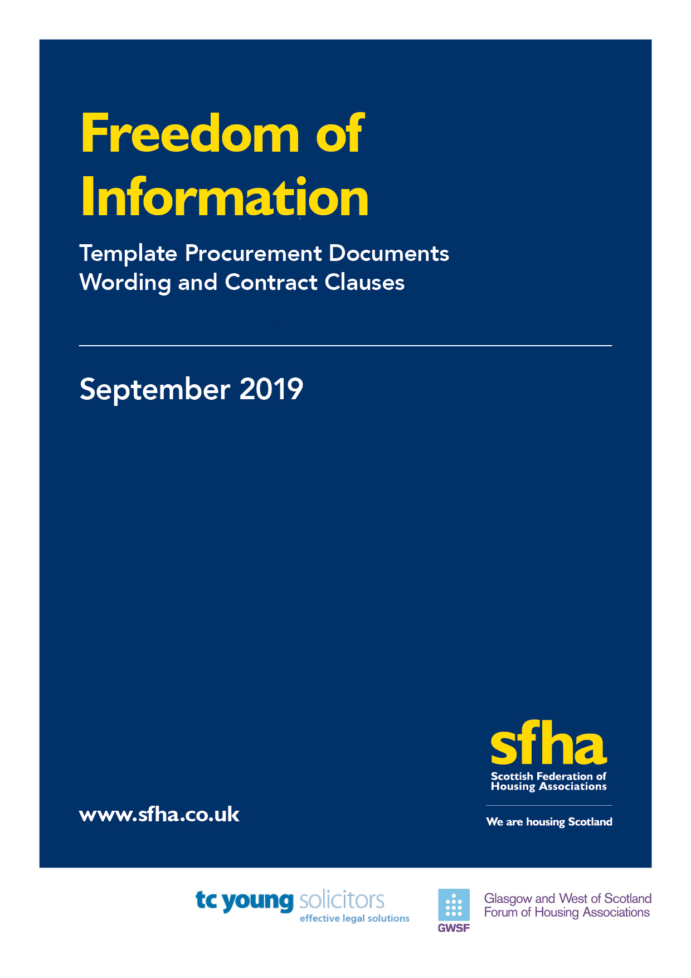

Contents

Introduction p1
- Background to template procurement wording p1
- Background to template contract clauses p2
- Pre-FOI contracts p3
Appendix A – Template procurement wording p4
- Short form procurement wording p5
- Long form procurement wording p6-7

Appendix B – Template contract clauses p8
- Short form contract clauses p9-10
- Long form contract clauses p11-13

Freedom of Information - Template Procurement Documents Wording and Contract Clauses
Introduction
This guidance has been drafted by TC Young on behalf of SFHA and GWSF. It provides members with templates and drafting notes to aid with procurement wording and contract clauses in respect of Freedom of Information requirements.

- Background to template procurement wording
Information that you receive from bidders during procurement exercises may have to be released in response to Information Requests (so, both requests made under the Freedom of Information Scotland Act 2002 (FOISA) and the Environmental Information (Scotland) Regulations 2004 (EIRs)). Handling requests of this nature can sometimes be challenging as:
- bidders may have a limited understanding of how FOISA or EIRs work; and
- tender documentation may contain information which is exempt from disclosure under FOISA or EIRs – generally because its release would cause harm to commercial interests or the information itself is subject to a duty of confidentiality.
From the outset of any procurement exercise it is important to ensure that: bidders are aware that information provided may be subject to disclosure or publication and any information that may be commercially sensitive or confidential is flagged as such. This is to ensure that bidders’ commercial interests are respected.
However, it is equally important to ensure that you are entitled to release information in accordance with FOISA and EIRs as and when required.
This is why having clear FOI/EIR provisions in procurement documentation is crucial.
The sections at Appendix A set out model terms that you may wish to incorporate into your procurement documentation (for example Invitations to Tender) and reflect what is recommended by the Scottish Minister’s Section 60 Code of Practice.
This wording is designed and intended only for use as a template which will require to be adapted to meet the requirements of any transaction in which it is used. The style of wording may not be appropriate for all tenders and you should work with your procurement teams and take appropriate advice to determine what wording should be included in any tender documentation you produce.

- Background to template contract clauses
You may be asked to share information about contracts you have with third party contractors – and under FOISA and EIRs will be obliged to disclose this information unless a relevant exemption applies. Handling requests of this nature can often be challenging as:
- contractors may have a limited understanding of how FOISA or EIRs work;
- contract documents, or anything produced in relation to a contract, may contain information which is exempt from disclosure under FOISA or EIRs – generally because its release would cause harm to commercial interests; and
- the contract may place an obligation on you to keep all information relating to the contract confidential.
It is important that contractors are clear about your obligations under FOISA and EIRs. It is also important to remember that the Scottish Information Commissioner’s (SIC) position is that:
- where a contract has been negotiated SIC is unlikely to accept that information in that contract is subject to the confidentiality exemption in section 36(2) of FOISA;
- you should not accept blanket confidentiality clauses (or other confidentiality restrictions) in any contracts unless you can demonstrate a good reason for this.
So, when entering into contracts it is important to ensure that contractors are aware of your duties under FOISA and EIRs – as well as that any obligations regarding confidentiality are appropriate.
The Section 60 Code of Practice also recommends that contracts include:
- disclosure provisions;
- an annex or schedule which sets out what information under the contract is considered to be commercially sensitive (where appropriate taking into account the nature of the contract); and
- an obligation on you to attempt to consult with contractors where you receive a request for information which is identified as sensitive.
The section at Appendix B contains model contract clauses which you could insert into your contracts to cover the above points.
This wording is designed and intended only for use as a template which will require to be adapted to meet the requirements of any transaction in which it is used. The style of wording may not be appropriate for all contracts and you should take advice where appropriate.

- Pre-FOI contracts
Contracts that existed before 11 November 2019 will still be subject to FOISA and/or EIRS, however many of these contracts may have:
- blanket confidentiality wording; and/or
- little to no acknowledgement of your duties under FOISA and EIRs

You may need to consider:
- Option 1: updating existing contracts in order to incorporate the template wording in Appendix B. How you approach this will depend on the wording of the contract and your relationship with the relevant contractor - however it is likely that both you and the contractor would need to sign an Amendment Agreement; or

- Option 2: contacting current contractors in order to explain your new duties under FOISA and EIRS - in particular making it clear that information relating to the contract may need to be disclosed in response to an FOI or EIR request. In these circumstances it is also recommended that you work with your contractors in order to develop a consultation process in respect of such requests that relate to contractual information.

What approach you take will depend on the nature of the individual contracts in question - and it may be that, for some contracts, looking to enter into Amendment Agreements or set up consultation processes will be unnecessary and disproportionate.
When identifying: contracts that may need to be amended or have consultation processes put in place you should follow the Section 60 Code of Practice and focus on contracts which are:
- high value;
- critical to your core functions;
- controversial;
- long term; or
- likely to be the subject of FOI/EIR requests

Finally, given that EIRS have applied to the sector since 2014, it may be that contracts contain provisions in respect of EIRs – but do not provide for FOISA. Again, contracts should either be amended (likely via an Amendment Agreement) to refer to your obligations under FOISA as per Option 1 or, as per Option 2, contractors should be notified of your FOISA duties and a consultation process agreed. As before – the exact approach you take (if any) will depend on the nature of the contract.

Short Form Procurement Wording
Drafting Notes:
- this wording is intended for tenders which are low value and relate to the procurement of services, works and goods which are not: critical to your core functions; long term or likely to be controversial.
- you should use an appropriate heading for this section such as ‘Freedom of Information’ when inserting into your document.
- the wording in bold square brackets should be updated to reflect the language used in your tender documents. You may also want to change the layout of the wording in order to reflect the style of your tender documents.
All information submitted to [Organisation] may need to be disclosed in response to a request for information made pursuant to the Freedom of Information (Scotland) Act 2002 (“FOISA”) and/or the Environmental Information (Scotland) Regulations 2004 (“EIRs”) or may need to be published under [Organisation’s] publication scheme - unless such information falls within an exemption under FOISA and/or EIRs. The decisions of the [Organisation] in the interpretation of FOISA/EIRs shall be final and conclusive.
If [Bidders] consider that any information included in their submission is commercially sensitive and/or confidential, they should identify the information and explain what harm may result from disclosure and the time period applicable to that sensitivity. Where a request received under FOISA or EIRs relates to information that a [Bidder] has identified as commercially sensitive and/or confidential [Organisation] shall undertake to (insofar as it is reasonable to do so) consult with the [Bidder] before replying to such a request. It should be noted however that even where [Bidder] has indicated that information is commercially sensitive and/or confidential the [Organisation] (in its sole discretion) may be required to disclose or publish said information under FOISA/EIRs.
[Bidders] should note that receipt of any material marked ‘confidential’ or equivalent should not be taken to mean [Organisation] accepts any duty of confidence by virtue of such marking.

Long Form Procurement Wording
Drafting Notes
- this wording is intended for tenders which are high value and relate to the procurement of services, works and supplies which are: critical to your core functions; long term or likely to be controversial.
- the long form wording is made up of two parts. Section 1 should be inserted in the body of any ITT or other procurement document. It highlights your obligations under FOISA and EIRs to bidders and makes it clear you may need to disclose information submitted. Section 2 should be inserted as an appendix or schedule to your Invitations to Tender or other procurement documentation (but not ESPDs). It requires bidders to identify any information included in their submission which they consider to be commercially sensitive and any instructions given to bidders should clearly state that this section should be completed.
- you should use appropriate headings for each section when inserting into your documents.
- the wording in bold square brackets should be updated to reflect the language used in your tender documents. You may also want to change the layout of the wording in order to reflect the style of your tender documents.
Section 1
All information submitted to [Organisation] may need to be disclosed in response to a request for information made pursuant to the Freedom of Information (Scotland) Act 2002 (“FOISA”) and/or the Environmental Information (Scotland) Regulations 2004 (“EIRs”) or may need to be published under [Organisation’s] publication scheme - unless such information falls within an exemption under FOISA and/or EIRs. The decisions of [Organisation] in the interpretation of FOISA/EIRs shall be final and conclusive in any dispute, difference or question arising in respect of disclosure under their terms.
If [Bidders] consider that any information included in their submission is commercially sensitive and/or confidential, they should, by completing [insert reference to relevant annex or schedule], identify the information and explain what harm may result from disclosure and the time period applicable to that sensitivity. Where a request received under FOISA or EIRs relates to information that a [Bidder] has identified as commercially sensitive and/or confidential [Organisation] shall undertake to (insofar as it is reasonable to do so) consult with the [Bidder] before replying to such a request. It should be noted however that even where [Bidders] have indicated that information is commercially sensitive and/or confidential the [Organisation] (in its sole discretion) may be required to disclose or publish said information under FOISA/EIRs.
[Bidders] should note that receipt of any material marked ‘confidential’ or equivalent should not be taken to mean [Organisation] accepts any duty of confidence by virtue of such marking.
Section 2
[Schedule or Appendix Heading]
Commercially Sensitive Information
[Bidders] should list here any information forming part of their submission which they consider to be genuinely commercially sensitive. Bidders should also, insofar as they are able to do so, identify why the information is confidential and/or commercially sensitive and how long it is likely to be so.
Where [Organisation] receives a request for the information noted below during the relevant period of sensitivity, it shall, insofar as it is reasonable to do so, seek to consult with the relevant [Bidder] as to whether or not any relevant exemptions apply under FOISA and/or EIRs. However [Bidders] acknowledge that, [Organisation] may, in its sole discretion, have to disclose the information noted below in accordance with their obligations under FOSIA and/or EIRs.
Commercially Sensitive Information
Information | Reason for Sensitivity | Duration of Sensitivity

Short Form Contract Clause
Drafting Notes:
- this wording is intended for commercial transactions and is not suitable for use in consumer transactions. It is prepared on the assumption that both parties to the contract are based in the UK.
- the Short Form Clause is intended to be used in contracts which: due to their nature, style or the parties involved would make using the Long Form Wording inappropriate.
- the wording in bold square brackets should be updated to reflect the language used in your contract documents. You may also want to change the layout of the wording in order to reflect the style of your contract documents (for example the section numbering may need to be amended).
- [Freedom of Information]
  - The [Contractor] acknowledges that [Organisation] is subject to the requirements of the Freedom of Information (Scotland) Act 2002 and the Environmental Information (Scotland) Regulations 2004 (“Information Legislation”) and shall:
    - provide (at its own expense) all assistance and cooperation as reasonably requested by the [Organisation] to comply with its obligations under the Information Legislation;
    - transfer to the [Organisation] any request (or apparent request) for information under the Information Legislation (a “Request for Information”) relating to this [Agreement] that it receives as soon as practicable and in any event within 2 working days of receipt;
    - provide the [Organisation] with a copy of all information belonging to the [Organisation] requested in a Request for Information which is in its possession or control in the form that the [Organisation] requires within 5 working days (or such other period that the [Organisation] may reasonably specify) of the [Organisation’s] receipt of the Request for Information; and
    - not respond directly to a Request For Information unless authorised in writing to do so by the [Organisation].
  - If the [Contractor] considers that all or any information provided to the [Organisation] under this [Agreement] a “trade secret” in accordance with the Information Legislation or is commercially sensitive information disclosure of which would be likely to prejudice the commercial interests of any party in accordance with the Information Legislation, or a duty of confidentiality applies under the Information Legislation, or is exempt by the operation of any other provision the Information Legislation, the [Contractor] shall ensure that the relevant Information, the claimed exemption or exception and if a qualified exemption, its views on where the public interest lies, is clearly identified to the [Organisation].
  - The [Contractor] acknowledges that the [Organisation] may be required under the Information Legislation to disclose information concerning the [Contractor] or [[Services][Works][Goods] [Drafting Note: insert reference to whatever is being provided under the Contract]] including information which the [Contractor] may have identified to the [Organisation] in accordance with [clause 1.2 above] without consulting or obtaining consent from the [Contractor]. The [Organisation] shall take reasonable steps to notify the [Contractor] of a Request For Information (in accordance with any relevant guidance issued under the Information Legislation) to the extent that it is permissible and reasonably practical for it to do so, but (notwithstanding any other provision in this [Agreement]) the [Organisation] shall be responsible for determining in its absolute discretion whether any information relating to the [Agreement] or [[Services][Works][Goods] [Drafting Note: insert reference to whatever is being provided under the Contract]] is exempt from disclosure in accordance with the Information Legislation.

Long Form Contract Clause
Drafting Notes:
- this wording is intended for commercial transactions and is not suitable for use in consumer transactions. It is prepared on the assumption that both parties to the contract are based in the UK.
- the wording in bold square brackets should be updated to reflect the language used in your contract documents. You may also want to change the layout of the wording in order to reflect the style of your contract documents (for example the section numbering may need to be amended).
- the Long Form Wording is split into 3 sections:
  - Section 1: Definitions
  - Section 2: Freedom of Information Clause
  - Section 3: Commercially Sensitive Information Schedule
- each section has its own drafting notes that you should refer to
Section 1: Definitions
Drafting Notes: you should insert the definitions listed here into any definitions section in your contract. If your contract has no definitions section you will need to consider how to incorporate these definitions into the body of the Contract
Commercially Sensitive Information: the information listed in [insert reference to schedule or annex] comprising the information of a commercially sensitive nature relating to the [Contractor], its intellectual property rights or its business that if disclosed by [Organisation], would cause the [Contractor] significant commercial disadvantage or material financial loss, including any Contractor’s Confidential Information.
Contractor’s Confidential Information: any information, however it is conveyed, that relates to the business, affairs, developments, trade secrets, know-how, personnel and suppliers of the [Contractor], including intellectual property rights, together with all information derived from the above.
FOISA Code: means the Scottish Ministers’ Code of Practice on the Discharge of Functions by Scottish Public Authorities under the Freedom of Information (Scotland) Act 2002 and the Environmental Information (Scotland) Regulations 2004.
Information: has the meaning given under section 73 of the Freedom of Information (Scotland) Act 2002.
Information Legislation: means the Freedom of Information (Scotland) Act 2002 and the Environmental Information (Scotland) Regulations 2004.
Request for Information: a request for information or an apparent request under the Information Legislation.

Section 2: Contract Wording
Drafting Notes: you should insert this section into the body of your contract. You will need to consider if any of the language or provisions need to be changed to account for any other provision in the contract.
- [Freedom of Information]
  - The [Contractor] acknowledges that [Organisation] is subject to the requirements of the Information Legislation and shall:
    - provide (at its own expense) all assistance and cooperation as reasonably requested by the [Organisation] to comply with its obligations under the Information Legislation
    - transfer to the [Organisation] all Requests for Information relating to this [Agreement] that it receives as soon as practicable and in any event within 2 working days of receipt;
    - provide the [Organisation] with a copy of all Information belonging to the [Organisation] requested in a Request for Information which is in its possession or control in the form that the [Organisation] requires within 5 working days (or such other period that the [Organisation] may reasonably specify) of the [Organisation’s] request for such information; and
    - not respond directly to a Request For Information unless authorised in writing to do so by the [Organisation].
  - If the [Organisation] receives a Request for Information concerning the [Agreement], the [Organisation] is responsible for determining at its absolute discretion whether the information requested is to be disclosed to the applicant or whether the information requested is exempt from disclosure in accordance with the Information Legislation, notwithstanding any other terms of this [Agreement].
  - The [Contractor] acknowledges that the [Organisation] may, acting in accordance with the recommendations set out in the FOISA Code, be obliged under the Information Legislation to disclose Information:
    - without consulting the [Contractor]; or
    - following consultation with the [Contractor] and having considered its views.
  - Where [clause 1.3.1] applies the [Organisation] shall, insofar as it is practicable to do so, give the [Contractor] advance notice of the disclosure or, failing that, draw the disclosure to the attention of the [Contractor] after such disclosure
  - Where a Request for Information concerns Commercially Sensitive Information specified in [insert reference to relevant schedule or annex] (having regard to the justifications and durations set out there), the [Organisation] must take reasonable steps, where practicable, to consult with the [Contractor] before disclosing it pursuant to a Request for Information or publishing it in accordance with its duties under the Information Legislation (declaring however that the final decision as to whether or not to disclose or publish said information shall rest with the [Organisation], notwithstanding any other terms in this [Agreement]).

Section 3: Commercially Sensitive Information Schedule
Drafting Notes: this section should be inserted at the end of your Agreement with any other Schedules or Annexes. You should ask the Contractor to fill out this section and work with them in order to agree suitable wording here.
[Schedule or Appendix Heading]

Commercially Sensitive Information

Information specified as commercially sensitive | Reason why information is commercially sensitive | Duration of commercial sensitivity

Scottish Ministers (Dec 2016) Section 60 Code of Practice

