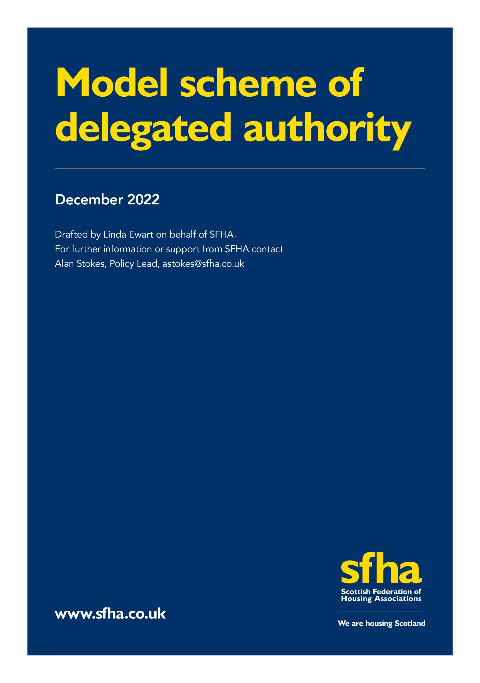

SFHA Model Scheme of Delegated Authority

This template is intended to provide a high-level Framework for RSLs who are reviewing and/or developing their delegated authorities. Ensuring that there are clear arrangements for delegation and effective reporting arrangements will support RSLs in operating to high standards of governance and demonstrating compliance with Regulatory Standards, specifically Standards 1.2 and 1.5.
This template focusses on the division of responsibilities between the governing body (GB) and the senior officer. There is, of course, scope for further delegation from the governing body to sub-committees and working groups and from the senior officer to members of the senior management team (and further onward delegation of operational authorities), depending on the governance and organisational structures of individual RSLs.
This model Framework is, by necessity, high-level. Each RSL will wish to customise their Scheme of Delegated Authority (SoDA) to reflect their individual governance and organisational structures (e.g. by defining the level of the GB’s involvement in staffing/employment matters, arrangements for wage negotiations (and taking account of any collective membership / negotiating bodies); sub-committee structure; number of office-bearers; senior management structure etc). The GB may delegate some of its responsibilities to the Chair and other office bearers (OBs) such as annual reviews, dealing with complaints relating to Code of Conduct. Similarly, the senior officer will delegate specific responsibilities to senior management colleagues, in accordance with approved role descriptions & organisational structure.
The model is not intended to be prescriptive; it reflects the SFHA model Rules and existing good governance guidance, as well as Regulatory Standards. It does not extend to those matters normally contained within financial regulations which, like the SoDA, normally form part of an RSL’s Standing Orders. All of these documents must be specific to each individual RSL: the model SoDA is intended to be used as a reference point for review and development of the specific arrangements that each SFHA member requires to support good governance and effective operations. In presenting their specific framework, individual organisations may find it useful to link, electronically, their SoDA to relevant key internal documents, such as Rules and Financial Regulations.

Area of Responsibility | Governing Body | Senior Officer
Role | Approval for strategy, policy, performance, implementation and variation | Accountable to GB and responsible providing advice and support by producing reports, discussion documents, strategies etc;  ensuring the provision of appropriate/relevant professional and independent advice
Mission, Vision, Values | Purpose and focus  Aim(s)  Principles (e.g. fairness, transparency, engagement, accountability) | Operational delivery  Evidencing implementation via operating practices
Organisational Culture | Defining expectations as to how the values will be exhibited in e.g. service delivery, communication, employment – reflected in policies and organisational practice | Evidencing implementation  Advising GB on policy considerations /implications  Overseeing effective implementation throughout organisation (policy development, implementation, practice)  Effective/appropriate delegation to senior staff
Strategic/Business/Corporate Plan | Approving long- and medium-term strategic plan(s)  Business planning  Strategy and Development Funding Plan (SDFP)  Oversight/monitoring implementation & outcomes  Approving/overseeing recovery/remedial action  Approving & overseeing implementation of business development plans | Advising GB  Accessing appropriate specialist/ professional advice  Developing/drafting plans and strategies for consideration  Supporting effective GB engagement in planning  Evidencing/reporting to GB on implementation/performance/ outcomes  Exercising operational control and direction  Initiating actions; monitoring outcomes;
Long-and short-term financial planning/ management | Financial forecasts demonstrating viability  Assumptions – ensuring reasonableness  Scenario planning & stress testing  Treasury management policy/strategy & planning  Approving investment institutions, instruments and terms  Approving borrowing terms  Approving the opening and closing of bank accounts  Agreeing thresholds for executive delegation (e.g. short-term deposits)  Approving application(s) for company credit card(s); authorising users; agreement of individual and collective thresholds | Advising and supporting GB  Accessing appropriate specialist / professional advice  Developing policies and strategies  Evidencing/reporting to GB on implementation  Monitoring performance / trends / outcomes  Maintaining covenant compliance  Managing borrowing and investments  Overseeing SMT exercise of delegated authorities  Evidencing compliance with policy & GB decision-making
Risk | Identification & review of key strategic/ operational risks  Identification of risk appetite  Approval of risk management framework | Implementing operational risk management  Evidencing effective implementation  Management; mitigation & monitoring of all risks  Maintaining adequate insurance  Maintenance of up-to-date stock condition information
Finance & Budget | Recommend appointment of Auditors to AGM  Consider annual Management letter/Letter of Representation  Annual budget approval  Annual rent increase  Periodic budget oversight & monitoring  Approval of budget variances above agreed thresholds | Implementing and ensuring achievement of budget  Preparation of all management reports  Presentation of supporting information/evidence to inform GB decision-making  Approving budget virement within delegated authority
Legal Compliance | Health and safety  Employment  Tenancy (including allocations & lettings)  Homelessness  Environmental  Equalities  Freedom of Information  Charities  Whistleblowing  Contractual terms  Public Procurement  Statutory Consent | Advising GB on all obligations  Ensuring and evidencing organisational compliance  Effective delegation  Ensuring access to required knowledge & expertise (internal & external sources)  Maintenance & implementation of all organisational policies  Implementing & observing all safety requirements  Maintaining all necessary certificates  Ensuring implementation of all necessary procedures (internal and external) to achieve compliance
Regulatory Compliance | Ensuring compliance with Regulatory Standards of Governance and Financial Management; overseeing/maintaining evidence of compliance  Approving Annual Assurance Statement; oversight of implementation of improvement plans  Ensuring timely submission of all required regulatory returns  Appointing internal auditors; approval of annual IA plan  Approving:  - ARC  - Five/Thirty Year Financial Projections  - Loan Portfolio Return(s)  Ensuring compliance with Notifiable Events requirements; overseeing resolution of NEs  Obtaining required regulatory Consent(s)  Ensuring compliance with OSCR reporting requirements  Ensuring compliance with Companies House requirements | Preparation of all required submissions  Ensuring timely GB consideration Provision of all supporting information  Obtaining and reporting on independent validation  Development & maintenance of assurance evidence bank  Management of internal audit programme; development of management responses; reporting to GB  Implementation of IA recommendations  Preparation of all regulatory returns  Liaison with SHR
Constitutional Compliance | Ensuring compliance with:  Co-operative and Community Benefits Act (2014)  Companies Act (2006)  Charity Trustees and Investment (Scotland) Act (2005)  Approving Rules and amendments  Conduct of GB meetings in accordance with rules (e.g. quorum, minutes, conflicts of interest)  Conduct of AGM in accordance with Rules  Oversight of elections and retirals from the GB  Election of Chair and other office-bearers  Compliance with 9-year ‘rule’ | Ensuring & evidencing compliance  Supporting OBs & GB in fulfilling constitutional responsibilities  Obtaining legal/specialist advice to support compliance  Ensuring AGM and GB elections conducted as required  Ensuring all GB meetings are appropriately constituted, conducted & recorded  Supporting annual programme of GB reviews/appraisals  Supporting pro-active GB recruitment & succession planning
Tenant and Resident Safety & Quality Compliance | Ensuring compliance with:  - Health and Safety obligations  - SHQS  - EESSH (and subsequent development)  - SSHC  Oversight of Tenant Satisfaction Survey(s) | Delivery of all plans, strategies & actions to achieve & maintain standards  Preparation of all required records & returns  Evidencing/reporting compliance  Conduct of Tenant Satisfaction Surveys; reporting & acting on outcomes
Contract Compliance | Agreeing contract terms above executive thresholds (reactive & planned maintenance; energy efficiency; construction &/or development)  Oversight of contractual terms and their fulfilment  Agreeing litigation/contract challenge/ pursuing legal remedies for loss/damage | Negotiating contracts  Conducting due diligence  Obtaining professional/specialist advice, warranties etc.  Reporting to GB  Managing & monitoring contractor performance/delivery; instructing & overseeing remedial action as required
Employer Responsibilities | Approving Terms and Conditions of Employment  Recruiting CEO/Senior Officer  Appraising the CEO/senior officer’s performance  Recruitment to SMT posts (Tier 2)  Approving external accreditation strategies; overseeing maintenance  Ensuring disciplinary and grievance actions are conducted in accordance with agreed policies; participating as required by policies and operational delegation  Defending/pursuing employment-related litigation (e.g. Employment Tribunal | Monitoring/overseeing effective performance  Managing & supporting staff  Implementing staff appraisal programme  Implementing grievance and disciplinary processes as required
Performance Oversight | Agreeing performance standards  Reporting standards (frequency, scope, format)  Benchmarking; peer group selection | Delivery of services to tenants and other customers in accordance with all requirements & expectations  Supporting & acting on customer feedback; reporting to GB  Managing performance; evidencing & reporting to GB
Governance | Governance structure (establishment of sub-committee(s); agreement/variation of remits; establishment of working groups & agreement of remits  Approval and implementation of GB Code of Conduct  Implementation of processes to investigate complaints/alleged breaches of Code  Ensuring maintenance of Registers of Interest  Ensuring compliant management of potential conflicts of interest  Approving Standing Orders  Approving delegated authorities  Conduct of annual GB appraisals/reviews and action plans  Ensuring effectiveness of governance arrangements  Leadership of GB Recruitment and succession planning | Advising & supporting GB and sub-committees  Preparation of all reports & minutes  Implementation of GB learning & development and annual review programmes  Maintenance of all required records  Supporting GB in fulfilling governance responsibilities
Resource Planning / Management | Approval of organisational structure  Approval & oversight of implementation of employment policies  Ensuring the provision/availability of effective staff support and appraisal arrangements | Advising GB on resource requirements  Ensuring necessary staff complement, equipped with required knowledge, experience, skills  Provision of effective support, development, appraisal systems
Public Statements | Agreeing public statements Determining/approving corporate publication style | Making public statements on behalf of organisation in accordance with agreed policy & strategy

1.2: The RSL’s governance policies and arrangements set out the respective roles, responsibilities and accountabilities of the governing body and senior officers, and the governing body exercises overall responsibility and control of the strategic leadership of the RSL 1.5: All governing body members and senior officers understand their respective roles, and working relationships are constructive, professional and effective
Further guidance on internal audit available in SFHA Internal Audit guidance (updated June 2021)

